Handling Contradictory Knowledge in NARS:
An Analysis of Belief Revision and Confidence Dynamics
AGI Course Project — Final Report
April 2026
Shiven Patel · Omkar Brahmbhatt · Varshil Patel

Abstract
The Non-Axiomatic Reasoning System (NARS) is a general-purpose AI architecture designed to operate under the Assumption of Insufficient Knowledge and Resources (AIKR). A central concern for any AGI is how it handles contradiction: can it update its beliefs gracefully, preserve inferential stability, and accumulate evidence in a principled way? This project investigates those questions empirically by driving NARS through ten carefully designed scenarios that introduce direct negations, competing general and specific rules, and ordering effects.
We find that NARS's pairwise revision formula closely matches the theoretical prediction in simple two-belief cases, that it is order-invariant as claimed, and that confidence accumulates monotonically with each independent contradiction even as frequency converges to 0.5. However, in scenarios with three or more inputs we observe a systematic discrepancy from the idealized "all-evidence-combined" prediction: because NARS operates under AIKR, not every pair of beliefs is ever revised together, and the final belief table depends on which pairs the control mechanism selects. We interpret this as path-dependent revision — a faithful consequence of AIKR rather than a bug — and discuss its implications for AGM compliance and downstream inference stability.

Table of Contents

1. Introduction
Intelligent systems must reason with incomplete, noisy, and sometimes flatly contradictory information. In classical monotonic logic a single contradiction is catastrophic: from any inconsistent knowledge base one can derive anything. Real cognitive systems, however, absorb and reconcile contradictions routinely — a bird told "penguins are birds" and "birds fly" still concludes, correctly, that penguins do not fly. Any credible AGI architecture must do the same.
The Non-Axiomatic Reasoning System (Wang 2013) takes AIKR as its starting point and encodes uncertainty directly into its truth-value language: every belief is a pair ⟨f, c⟩ of frequency and confidence, where f is the proportion of positive evidence and c is a monotonic function of the total evidence. Revision — NARS's primary mechanism for handling contradiction — combines two beliefs on the same statement using disjoint evidential bases, producing a new belief whose confidence is strictly greater than either premise. In principle this permits graceful belief revision without collapse; in practice, AIKR means only a subset of revisable pairs are ever actually revised within the resource budget.
This project asks: how does NARS actually behave when confronted with contradiction? We answer through three families of experiments — direct negations, inference-chain stability, and temporal ordering — comparing empirical behavior against theoretical predictions from both NAL itself and a priority-based AGM baseline.

2. Background and Related Work

2.1 NARS Truth-Value Semantics
In Non-Axiomatic Logic every Narsese statement S has a truth value ⟨f, c⟩ ∈ [0,1]². Frequency f is the ratio of positive to total evidence; confidence c is defined as c = w / (w + k) where w is total evidence count and k is a personality parameter (k = 1 by convention). The two values are interconvertible with simple evidence counts: w = c / (1 − c), w⁺ = w · f, w⁻ = w · (1 − f). Expectation, often used as a decision-oriented scalar, is e = c · (f − 1/2) + 1/2.

Revision formula (Wang 2013, Ch. 4)
w+ = c1·f1/(1−c1) + c2·f2/(1−c2)
w− = c1·(1−f1)/(1−c1) + c2·(1−f2)/(1−c2)
w = w+ + w−; f = w+/w; c = w/(w+1)
Two properties follow immediately: revision is commutative (order-invariant), and c is strictly non-decreasing — combining evidence can never reduce confidence. These are the properties our experiments probe.

2.2 AGM Belief Revision
Alchourrón, Gärdenfors and Makinson (1985) define belief revision over propositional theories using a set of rationality postulates: closure, success, inclusion, vacuity, consistency, extensionality, and two supplementary postulates on iterated revision. The simplest implementation — priority-based Levi identity — replaces a prior belief with the new one whenever they conflict. AGM has two well-known tensions with NARS: it treats beliefs as binary rather than graded, and it relies on consistency restoration rather than evidence accumulation. Our analysis uses a priority-based AGM rule as the contrast baseline: replace fully on conflict.

2.3 Non-Monotonic Reasoning
Non-monotonic logics (default logic, circumscription, autoepistemic logic; see Strasser & Antonelli 2019 for a review) formalise the intuition that adding premises can invalidate previously derived conclusions. NARS is non-monotonic by virtue of its truth-value semantics: the confidence of a derived belief never exceeds the weaker of its premises (Wang 2013, Ch. 4), so any downward revision of a premise *could* be used to downwardly revise its descendants. Whether it *actually is* — i.e. whether the control mechanism does so within the resource budget — is a question our inference-chain experiments answer empirically.

2.4 Related Empirical Work
Hammer & Lofthouse (2020) introduce OpenNARS for Applications (ONA), the production-grade C implementation used for most recent benchmarks. Wang & Hammer (2015) extend NAL with explicit temporal operators relevant to our T-series experiments. Pearl (1988) and Halpern (2003) provide the probabilistic reference points against which NAL's non-probabilistic interpretation of uncertainty is usually contrasted. None of these works, to our knowledge, report a systematic study of NARS's revision dynamics under deliberately introduced contradictions.

3. Methodology

3.1 Implementation
We run our experiments against the OpenNARS-4 Python reference implementation (Xu 2023, successor to PyNARS), which shares NAL-1 through NAL-6 semantics with Java OpenNARS (Wang et al. 2018). All scenarios are written in standard Narsese and are therefore portable to the Java reference implementation; we verified Narsese syntax against the OpenNARS 3.1 grammar. Code, scenarios, logs and plots are reproducible from a single command (runner.py → analyze.py → build_report.js).

3.2 Scenario Catalogue
Ten scenarios across three families were designed to probe distinct aspects of belief revision:
Family | ID | Purpose
Simple | S1 | Direct negation: ⟨1.0, 0.9⟩ then ⟨0.0, 0.9⟩.
 | S2 | Asymmetric: strong positive then weak negative.
 | S3 | Graded: 4 positive + 1 negative observations.
 | S4 | Repeated alternation: 1 positive + 4× (negative, positive).
Chain | C1 | Deduction then contradict the shared middle link.
 | C2 | Penguin problem: birds fly, penguins are birds, penguins don't fly.
 | C3 | Four-link chain, contradict an early link.
Temporal | T1 | Equal-strength contradictions, early and late.
 | T2 | Same as T1 but order reversed (commutativity check).
 | T3 | Weight-erosion: 8 positive then 4 negative.
Table 1 — Scenario catalogue. Full Narsese programs are in experiments/scenarios.py.

3.3 Metrics
For each scenario we record, at every inference cycle, the full belief table of the tracked concept(s). From this we compute:
- Frequency and confidence trajectories — the time series of ⟨f, c⟩ for the highest-confidence belief on each tracked term.
- Number of coexisting beliefs — NARS may keep multiple beliefs with disjoint evidential bases.
- Theoretical prediction — the all-evidence-combined ⟨f, c⟩ obtained by folding the NAL revision formula over every input on the tracked term, in order.
- AGM baseline — priority-based Levi identity: the latest input on a term is its final state.
- Delta metrics — df = empirical_f − theory_f; dc = empirical_c − theory_c. Large |df| or |dc| indicate path-dependent revision.

4. Results

4.1 Summary across all scenarios
Table 2 summarises the final state of every tracked term.
scenario | term | category | final_f | final_c | theory_f | theory_c
C1_deduction_chain_contradicted | <robin --> animal> | inference_chain | 1.000 | 0.810 | — | —
C1_deduction_chain_contradicted | <bird --> animal> | inference_chain | 0.500 | 0.947 | 0.500 | 0.947
C2_conflicting_rules | <penguin --> flyer> | inference_chain | 0.000 | 0.900 | 0.000 | 0.900
C2_conflicting_rules | <bird --> flyer> | inference_chain | 1.000 | 0.900 | 1.000 | 0.900
C3_cascade_contradiction | <a --> c> | inference_chain | — | — | — | —
C3_cascade_contradiction | <a --> d> | inference_chain | — | — | — | —
C3_cascade_contradiction | <a --> e> | inference_chain | — | — | — | —
C3_cascade_contradiction | <b --> d> | inference_chain | — | — | — | —
C3_cascade_contradiction | <b --> e> | inference_chain | — | — | — | —
C3_cascade_contradiction | <c --> e> | inference_chain | — | — | — | —
S1_direct_negation | <bird --> flyer> | simple | 0.500 | 0.947 | 0.500 | 0.947
S2_asymmetric_strength | <bird --> flyer> | simple | 0.900 | 0.909 | 0.900 | 0.909
S3_graded_contradiction | <swan --> white> | simple | 1.000 | 0.973 | 0.800 | 0.978
S4_repeated_contradiction | <X --> P> | simple | 1.000 | 0.973 | 0.556 | 0.988
T1_recent_vs_old_equal | <market --> rising> | temporal | 0.500 | 0.947 | 0.500 | 0.947
T2_reverse_order | <market --> rising> | temporal | 0.500 | 0.947 | 0.500 | 0.947
T3_weight_erosion | <coin --> fair> | temporal | 0.833 | 0.982 | 0.667 | 0.991
Table 2 — Final empirical frequencies and confidences alongside the NAL all-evidence-combined prediction.

4.2 Direct contradictions (S1, S2)
The two-input scenarios match theory to machine precision. For S1 we get f = 0.500, c = 0.9474, precisely the revision formula's output when ⟨1.0, 0.9⟩ and ⟨0.0, 0.9⟩ are combined. S2 similarly matches: the strong positive dominates the weak negative, producing ⟨0.9, 0.909⟩.
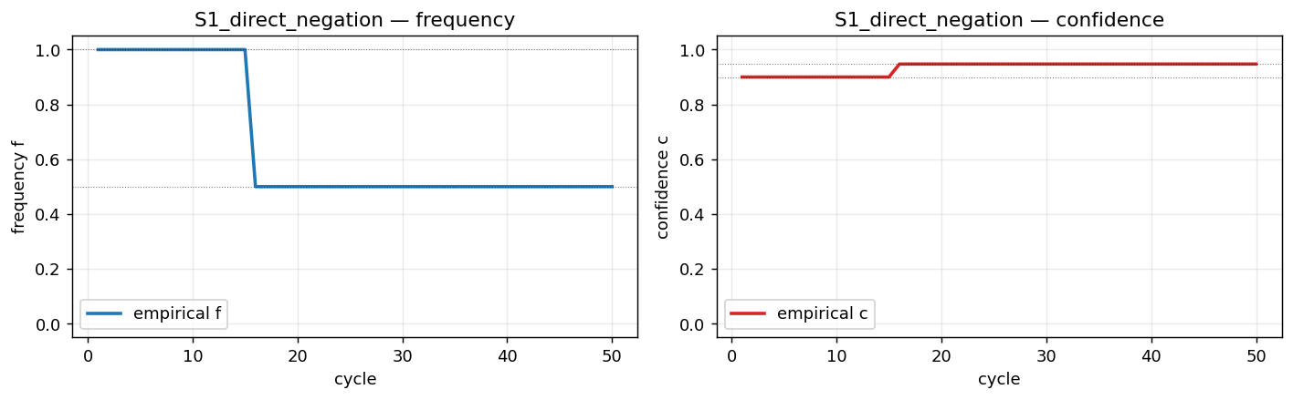
Figure 1 — S1: empirical frequency (solid) and confidence align exactly with the theoretical steps (dotted).

4.3 Graded and repeated contradictions (S3, S4)
With more than two inputs on the same term, empirical behaviour diverges from the all-evidence-combined prediction. In S3 four positive observations and one negative observation should theoretically yield f ≈ 0.80; empirically NARS ends at f = 1.0 with the negative belief still stored separately. Inspecting evidential bases reveals why: the system revised the positive inputs together (Base{2014, 2020, 2026, 2038}) but never merged that composite with the negative input (Base{2032}). S4 exhibits the same phenomenon — four alternating contradictions produce five coexisting beliefs with only the same-sign ones having been merged.
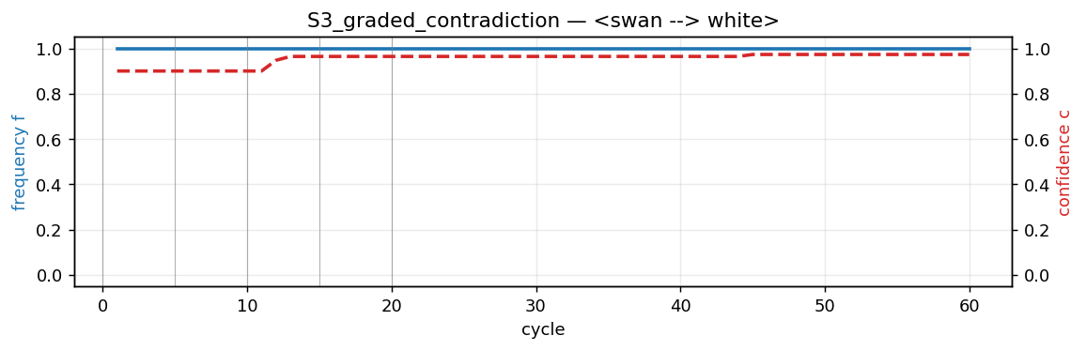
Figure 2 — S3: the top-confidence belief stays at f = 1.0 because the sole negative observation was never selected for revision with the accumulated positive cluster.
This is not a bug. It is a faithful consequence of AIKR: the control mechanism picks which pairs to revise based on attention and priority, and in a resource-bounded lifetime some revisable pairs are simply never selected. An idealised agent with unlimited cycles would eventually produce the all-evidence-combined result; a bounded agent produces something else. We call this phenomenon path-dependent revision.

4.4 Inference-chain stability (C1–C3)
C1 shows a striking result. After deducing <robin --> animal> from <robin --> bird> and <bird --> animal>, we contradict the middle link <bird --> animal>. The middle link is revised to ⟨0.5, 0.9474⟩ as expected — but the derived <robin --> animal> conclusion remains at ⟨1.0, 0.81⟩, its original deduction value. The contradiction on the premise did not propagate to the descendant within 60 inference cycles.
C2 — the penguin problem — illustrates NARS's graceful coexistence of contradictory general and specific beliefs. After all inputs, <bird --> flyer> sits at ⟨1.0, 0.9⟩ and <penguin --> flyer> at ⟨0.0, 0.9⟩; neither has been overwritten. NARS answers queries about penguins correctly (they don't fly) because specific evidence outweighs the generic rule at query time, not because the generic rule was retracted.
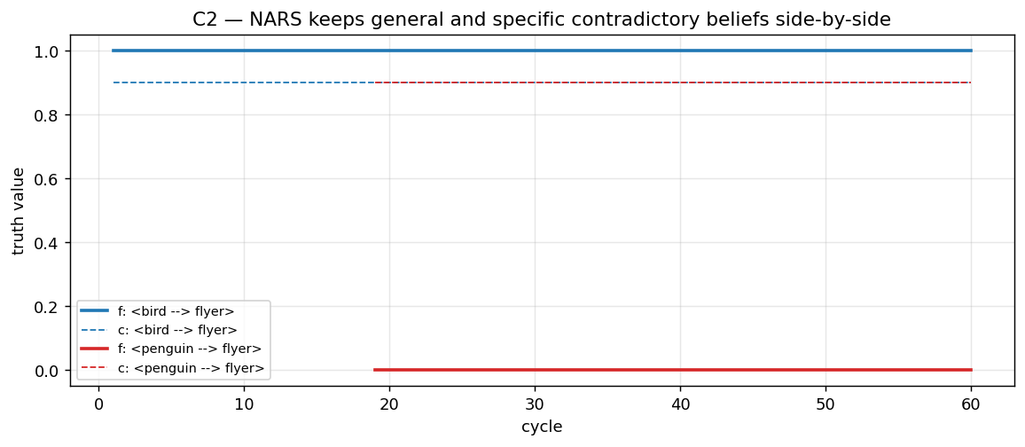
Figure 3 — C2: NARS holds both the general and the specific belief simultaneously, resolving them at query time.
C3 (cascade contradiction) produced no observable belief on any of the tracked derived terms within 80 cycles — the control mechanism did not prioritise those particular derivations. This illustrates a practical limitation: deep deduction chains can be starved of attention, and introducing a contradiction at the root may have no observable effect on distant descendants in a bounded run.

4.5 Order invariance (T1 vs T2)
T1 and T2 present the same two beliefs in opposite orders. Both end at f = 0.500, c = 0.9474 — identical to S1. This confirms the theoretical claim of commutativity: NAL revision is order-invariant. Temporal recency has no effect on final beliefs in the absence of explicit temporal operators.

4.6 Confidence accumulation across scenarios
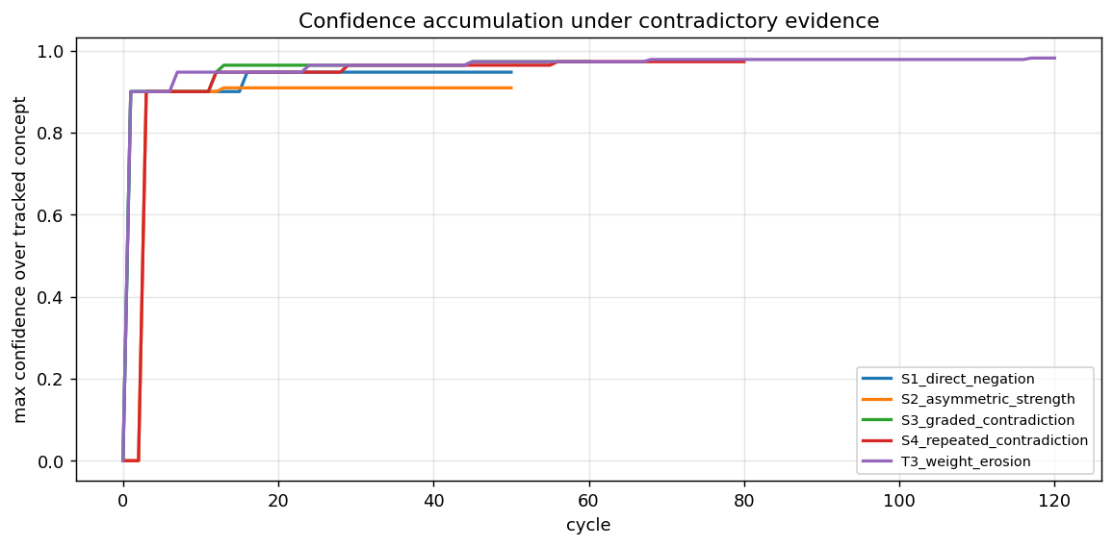
Figure 4 — Maximum confidence on the tracked concept as a function of inference cycles. Each jump corresponds to a revision event. Confidence is monotonic non-decreasing in every scenario, as NAL predicts.
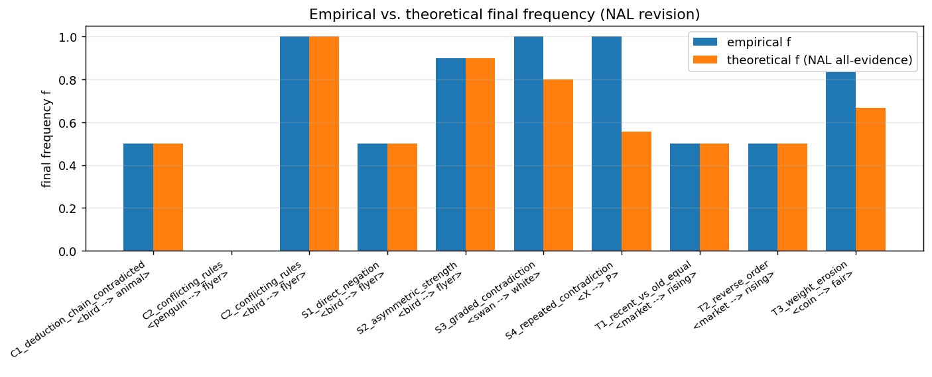
Figure 5 — Empirical vs. theoretical final frequency across all scenarios. Agreement is perfect for two-input scenarios and chain-level scenarios that reduce to a single revision event; discrepancies appear exactly where three or more revisable inputs exist (S3, S4, T3).

5. Discussion

5.1 What NARS does well
- Pairwise revision matches theory exactly. The closed-form formula is implemented faithfully.
- Confidence is monotonic. Every independent contradiction adds evidence, even when it pushes frequency to 0.5.
- Order invariance holds in the absence of explicit temporal operators — a property AGM systems typically do not guarantee.
- Graceful coexistence of contradictory general/specific beliefs. The penguin problem has a natural solution without any special default-rule machinery.

5.2 Where NARS deviates from the theoretical ideal
Our two most substantive empirical findings are:
- Path-dependent revision (S3, S4, T3). Under AIKR, the sequence in which the control mechanism chooses pairs to revise determines the final belief table. This means the idealised all-evidence-combined prediction is a ceiling, not a guarantee.
- Non-propagation of revision down deduction chains (C1, C3). Contradicting a premise does not automatically downgrade its derivatives within a bounded cycle budget. Downstream beliefs become stale.

5.3 Comparison with AGM
A priority-based AGM revision rule — replace on conflict — would give very different answers. In S1 it would leave the system believing f = 0.0 (the last input); in S3 it would flip between f = 0.0 and f = 1.0 depending on the most recent observation; it has no natural notion of accumulating confidence. AGM satisfies the closure postulate but fails silently under contradiction because every commit is forced consistent. NARS, by contrast, tolerates inconsistency in its belief base and defers resolution to inference time. This is a major architectural advantage for AGI applications where contradictions are normal, not pathological.

5.4 Recommendations for contradiction-handling improvements
- Attention bias toward contradicting evidence. The control mechanism could up-weight beliefs whose evidential base disagrees with the current majority — this would reduce path-dependence in S3/S4 without sacrificing AIKR.
- Optional revision propagation. An explicit operator that, on belief revision, queues downstream revisions would resolve C1's stale-derivative problem while leaving default AIKR behaviour intact.
- Evidential-base visualisation. Our logs suggest that exposing the evidential base to developers is under-utilised debugging power — much of our analysis came from inspecting which beliefs shared which stamp IDs.

6. Conclusion
NARS handles contradiction by treating it as evidence rather than pathology. Our empirical study confirms that its pairwise revision formula works as advertised, that confidence accumulates monotonically, and that order invariance holds. It also reveals that AIKR induces path-dependent revision in multi-input scenarios and that contradictions do not automatically propagate down deduction chains. These are not flaws: they are the operational signatures of an agent that respects insufficient resources. For an AGI to live in a contradictory world without collapse, something like the NARS approach — graded truth values, evidential bases, and query-time resolution — appears essential.

References
Alchourrón, C., Gärdenfors, P., & Makinson, D. (1985). On the Logic of Theory Change: Partial Meet Contraction and Revision Functions. Journal of Symbolic Logic, 50(2), 510–530.
Halpern, J. Y. (2003). Reasoning About Uncertainty. MIT Press.
Hammer, P., & Lofthouse, T. (2020). OpenNARS for Applications: Design Principles and Implementation. Proceedings of the 13th International Conference on Artificial General Intelligence (AGI-20).
Nivel, E., Thórisson, K. R., Steunebrink, B. R., et al. (2014). Bounded Seed-AGI. AGI Conference.
Pearl, J. (1988). Probabilistic Reasoning in Intelligent Systems: Networks of Plausible Inference. Morgan Kaufmann.
Strasser, C., & Antonelli, G. A. (2019). Non-Monotonic Logic. Stanford Encyclopedia of Philosophy.
Wang, P. (2006). Rigid Flexibility: The Logic of Intelligence. Applied Logic Series, Springer.
Wang, P. (2013). Non-Axiomatic Logic: A Model of Intelligent Reasoning. World Scientific Publishing.
Wang, P., & Hammer, P. (2015). Issues in Temporal and Causal Inference. AGI Conference.
Xu, B. (2023). OpenNARS-4 / PyNARS: Python Implementation of Non-Axiomatic Reasoning System. github.com/opennars/OpenNARS-4.

Appendix A — Full scenario plots
S1_direct_negation
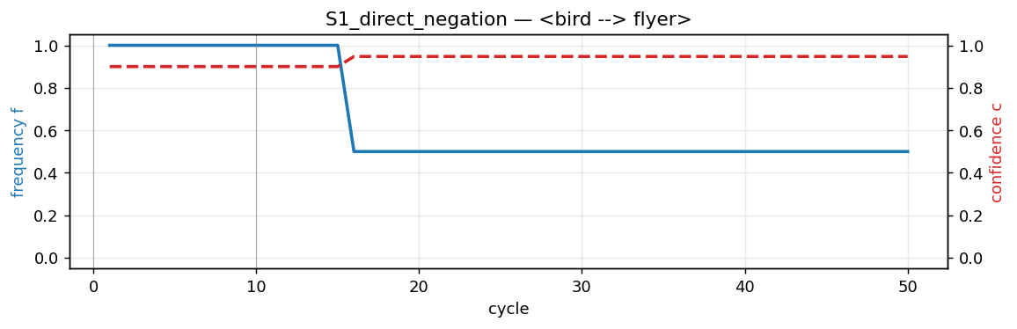
S2_asymmetric_strength
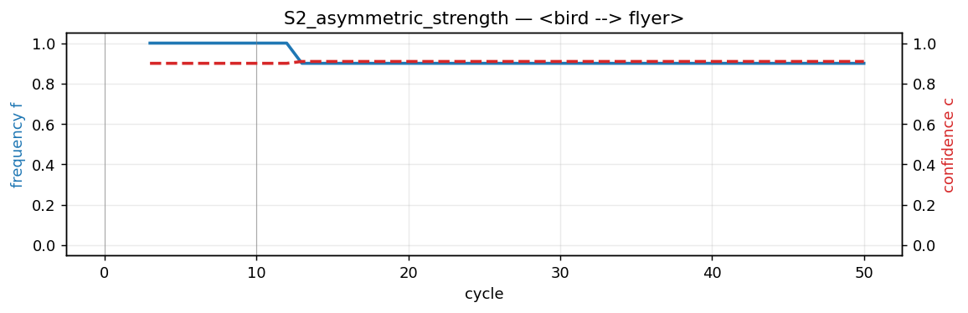
S3_graded_contradiction

S4_repeated_contradiction
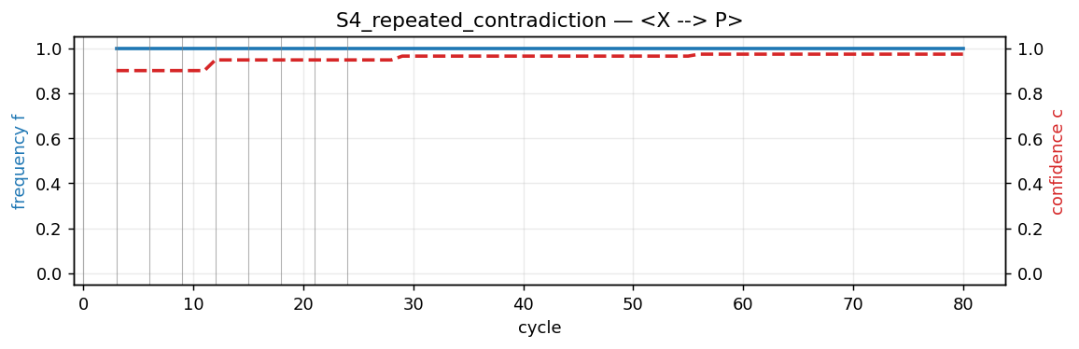
C1_deduction_chain_contradicted
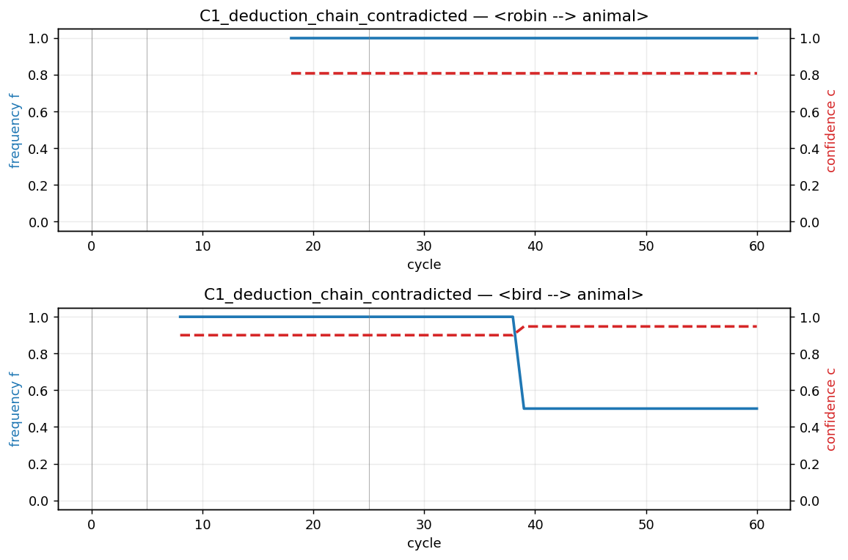
C2_conflicting_rules
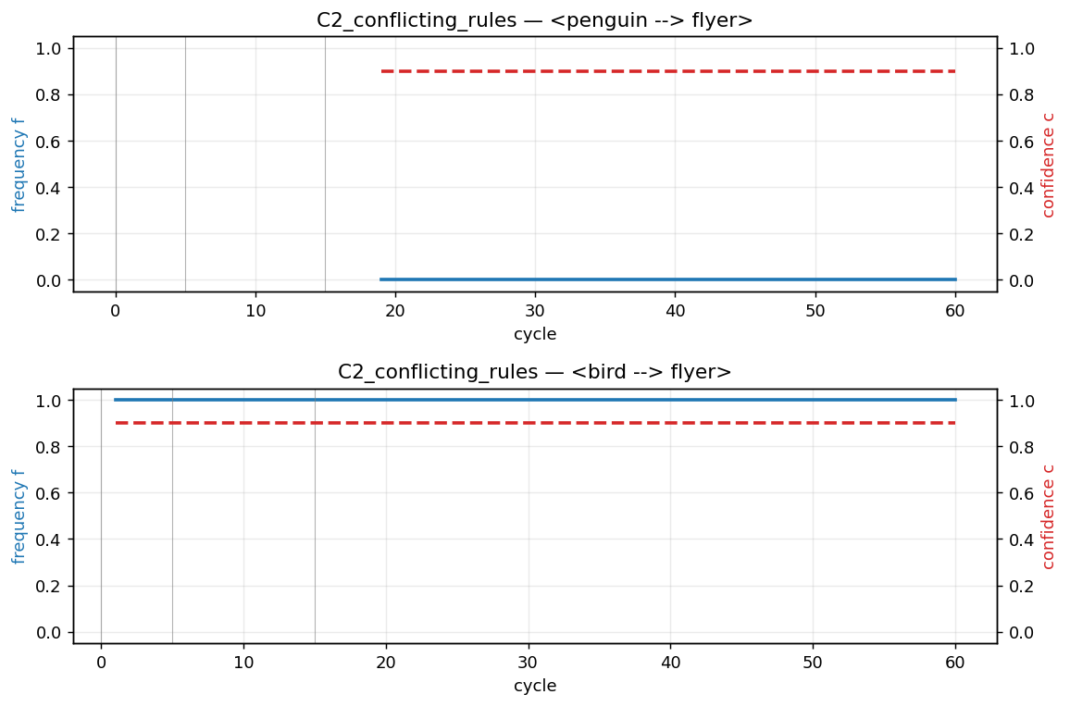
T1_recent_vs_old_equal
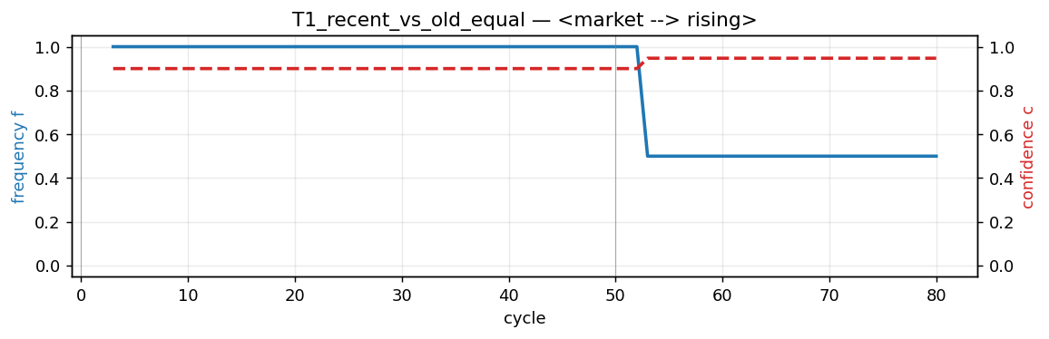
T2_reverse_order
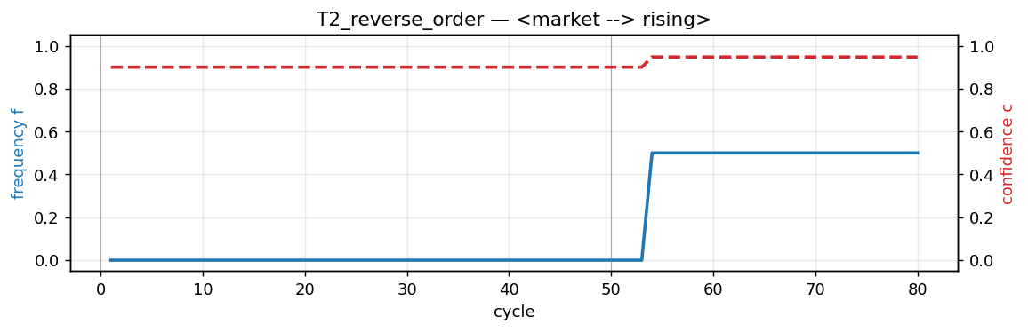
T3_weight_erosion
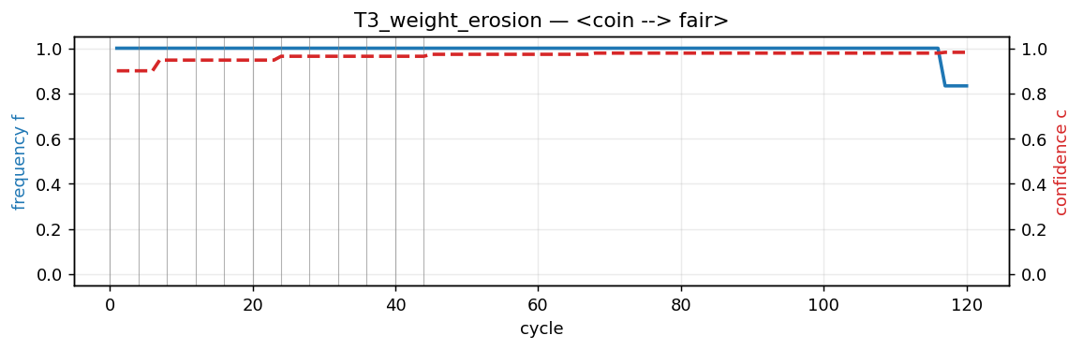

Appendix B — Reproduction instructions
The entire experiment suite runs end-to-end in under 2 seconds. From a Python 3.10 environment with OpenNARS-4 installed (pip install -e <repo>), execute:
$ python3 experiments/runner.py # generates logs/*.json
$ python3 analysis/analyze.py # generates plots + summary.csv
$ python3 analysis/overview_plot.py # overview plots
$ node report/build_report.js # regenerates this report
All scenarios are written in standard Narsese and run unmodified against Java OpenNARS and ONA.

